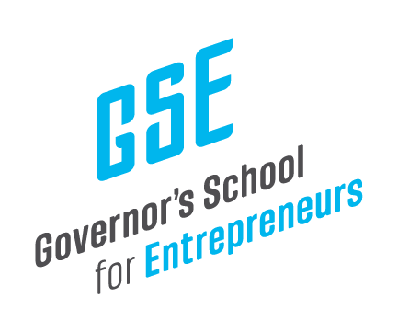

January 23, 2026

Mr. Jay Hartz
Legislative Research Commission Director
Sent Via Electronic Mail

Dear Mr. Hartz,

The Governor’s School for Entrepreneurs (GSE) is pleased to share the financial reports from our First Quarter, covering the months of October, November, and December 2025 for GSE’s FY25-26.

I’ve also attached our Audit for FY24-25 and our 2025 Impact Report.

I welcome any questions or feedback on these reports.

Kind regards,

Anne

Anne Jewell
President & CEO
Governor’s School for Entrepreneurs

